PHP Variables & HTML Input Form
Prepared: TrangNTT
Lab 2. PHP Variables & HTML Input Form 1
2.1. Create a PHP project 2
2.2. Expression Example 3
2.3. Create a String test 8
2.4. Create a Basic form 8
2.5. Create a registration form 9
2.6. Create a confirm form 9
2.7. Change to GET method 10
2.8. Firefox and Add-ons 10
2.9. Exercise 13

Create a PHP project
Check our first lab.

Expression Example (It can be different on Netbean)

Create a php file named “Expression Example”
- From the main menu, click File → New → PHP File. The New PHP File dialog appears.
- Enter the File Name is “Expression.php”. Click Finish.
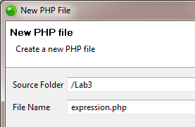
- Enter the following source code in the editor of expression.php
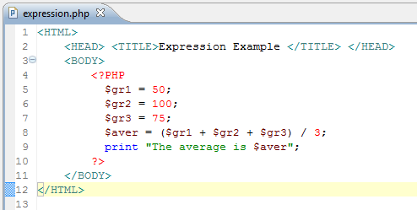

Run the Expression Example
- Right click on the editor or the expression.php file on the PHP Explorer, choose Run As → PHP Web page.
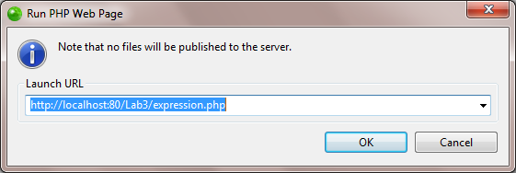

Create a String test
Do the same to create and run stringtest.php which includes all examples in the lecture.

Create a Basic form
Do the same to create and run basicform.php.
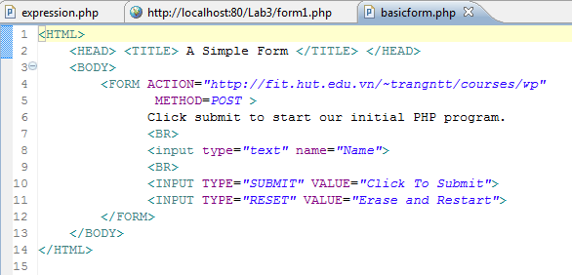

Create a registration form
Copy the basicform.php to registrationform.php which includes all HTML inputs in the lecture (refer to yahoo mail or gmail sign up).

Create a confirm form

Create Form4Radio.html
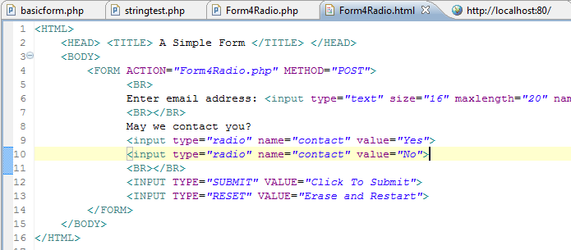

Create Form4Radio.php
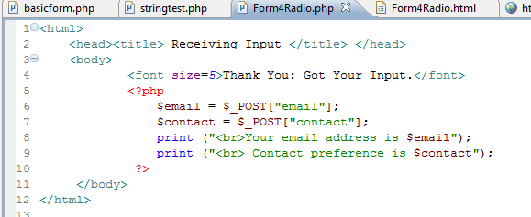

Run the Form4Radio.html
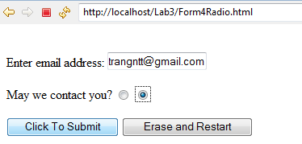

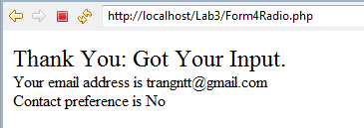

Change to GET method
Change the Form4Radio example from POST method to GET method. Observe the result and give comments.

Firefox and Add-ons

Install Firefox & Add-ons
- Install Firefox: http://www.mozilla.com/en-US/firefox/
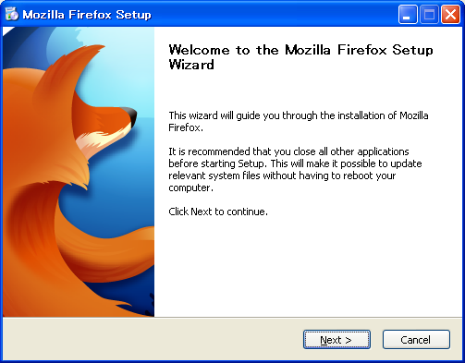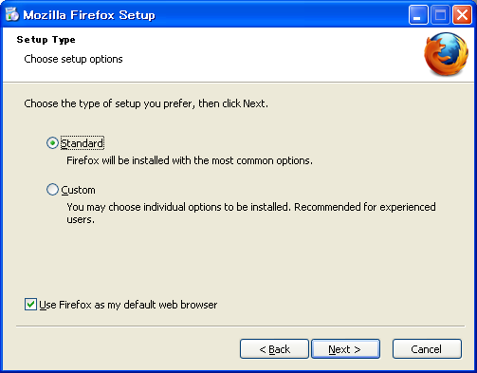

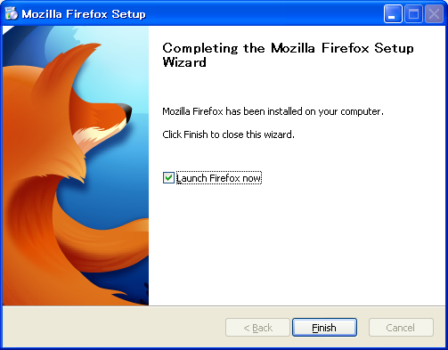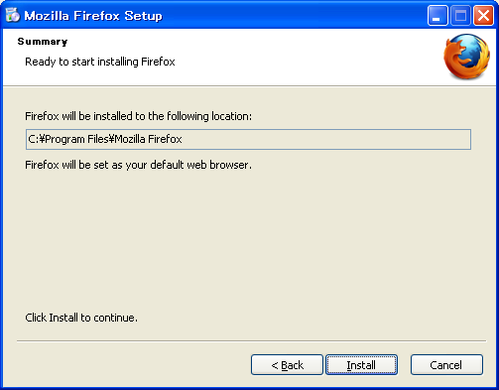
- Install Add-ons: DOM Inspector, Firebug and Web Developer
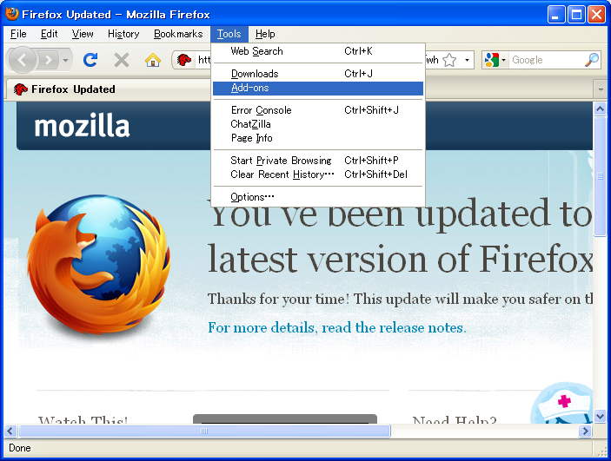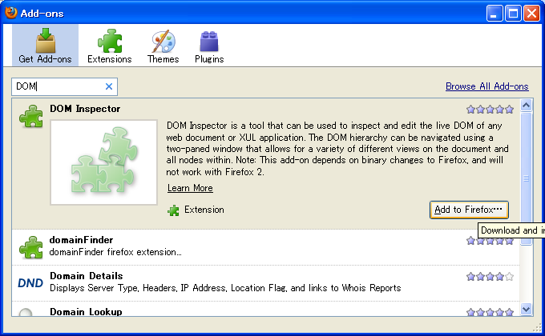
- Restart Firefox

Using DOM Inspector
- Practise steps:
  - Open Form4Radio.html in Firefox
  - Check DOM and other information by using DOM Inspector
- Additional guide:
Understanding the way a web page has been constructed is normally a case of viewing the source HTML and trying to build a mental picture picture of its structure, based on the way the different elements are nested within each other. It takes some practice, but it can be done. Much easier is to use a tool like the DOM Inspector, which lets us look at each part of the page, piece-by-piece, using a structured tree approach.
As an example I'll take the page I talked about in my last post. The first step is to browse to it in Firefox. Now launch the DOM Inspector from the Tools menu (Ctrl+Shft+I). You'll see a window something like this:
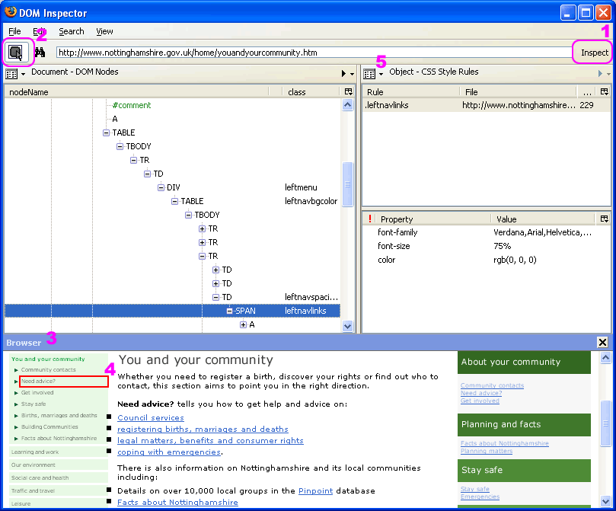
From the View menu enable the "browser" and make sure that Blink Selected Element is selected. The URL of the page you're interested in should already be the address bar at the top. Click on the Inspect button (highlighted by #1 in pink letters on the screengrab above) to the right of the address bar and it will load the page in the "browser" pane.
In order to find the part of the page you're interested within the document tree you can use two methods. The hardest is to drill-down through the tree, element by element, until that part of the page flashes (highlighted #4). Much easier is to click on the button (highlighted #2) that lets you simply click on said element to automatically find it in the tree. Click on one of the problems links with the small text and it will quickly that element, as shown above. In this case, the structured hierarchy of the link within the DOM is:
HTML > BODY > TABLE > TR > TD > TABLE > TR > TD > DIV > TABLE > TR > TD > SPAN > A

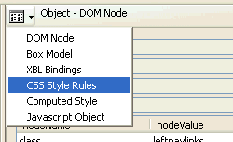
Armed with this information it is then fairly simple to work out which bits of the CSS stylesheet have an affect on the link element. How? Well, we can find out much more information about any given element node than simply its place in the document. Using the button highlighted at #5 we can choose to view different property-sets for the selected node. Switch to CSS Style Rules and you'll see all the styles applied to it. Work back through the tree and you'll see the other styles, some of which it inherits.
It's hard to sum up just how useful this tool can be. Hopefully this is a good example though. It may be a little rough around the edges but it's an extremely useful tool. Until recenlty I'd over-looked it and never bothered working out how to use it. Now I know how I'll probably be using it daily.
Here are some of the other uses and benefits of the DOM Inspector:
- Learn the strucuture of a HTML document.
- See how particular elements on a page are nested.
- Delete elements to see effect on page.
- Edit/change class names properties atrributes of elements
- Add attributes to the tree (In theory! This doesn't seem to work too well).

Using Firebug
- Firebug features:
  - Inspect custom stylesheets included by Google Mashup Editor
  - Modify in-memory stylesheets to see the changes reflected immediately
  - Place watches and breakpoints into running JavaScript
  - Execute arbitrary JavaScript in the context of your running application
  - Monitor Ajax calls, showing response times, posted content, and results
  - Profile JavaScript functions to help you identify bottlenecks and optimize your application.
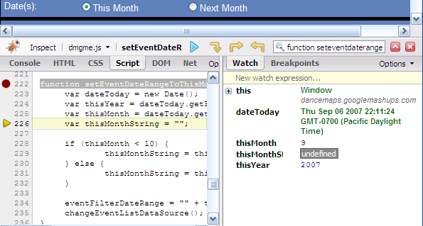
- Practise steps:
  - Open Form4Radio.html in Firefox
  - Check DOM and other information like HTML sources in Firebug
  - Browser web pages that you are interested in and check their information as well
  - Edit their HTML sources on the fly

Exercise
- Design a form including all types of HTML inputs which requests the users to fill their name, class, university, hobby (checkboxes to list some common hobbies and others), … (These fields are only for recommendation; you have to develop by yourselves other information which will help you get a higher score for this exercise).
- Then create a PHP file to process the action of the above HTML form. This PHP file will display all the information that users entered.
- Print all screens which you use add-ons of Firefox including DOM Inspector, and Firebug for the above exercise and paste to a MS Word document with a brief comment for each screen.
For example:
Hello, <username>
You are studying at <class>, <university>
Your hobby is
            - <hobby 1>
            - <hobby 2>
            - ...
...

